Booking Your Accommodation for Convention 2027
When you click the link below you will see this page. Select your dates, how many rooms and up to 3 guests (if there are 4 of you, you will need to book for 3 as they do not allow 4 guests in a room). If you are sharing a room, only 1 guest needs to book. Payment is not taken at this stage. Credit Card details are purely to reserve your room
Red Hat Convention 2027 - book now (click to go to website)
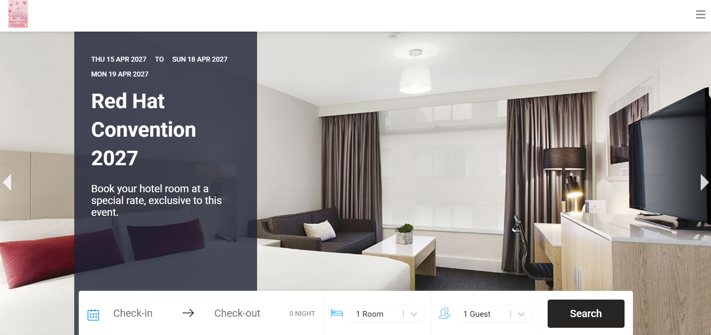

You will see 2 hotels. Choose the Mecure or the Pullman. Both are in the same building and all facilities are available to all guests.
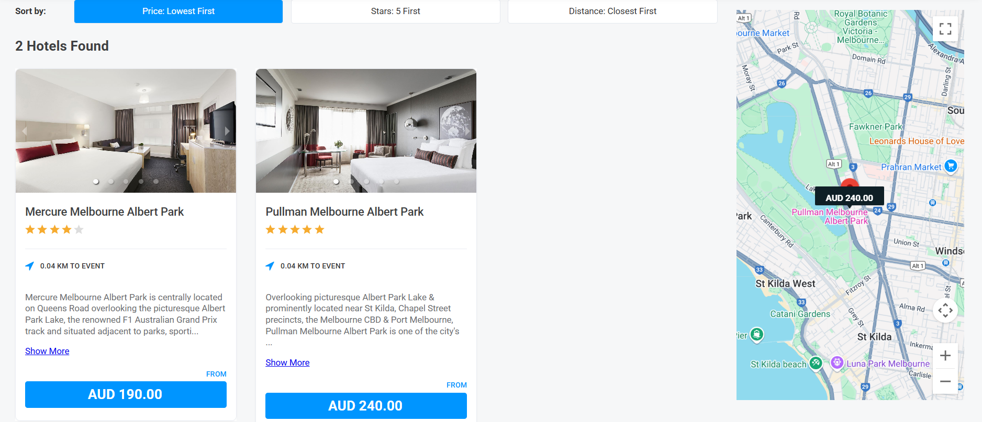

You will then see a selection of rooms with different bed configurations. Click one which suits you and you can also select a discounted breakfast rate.
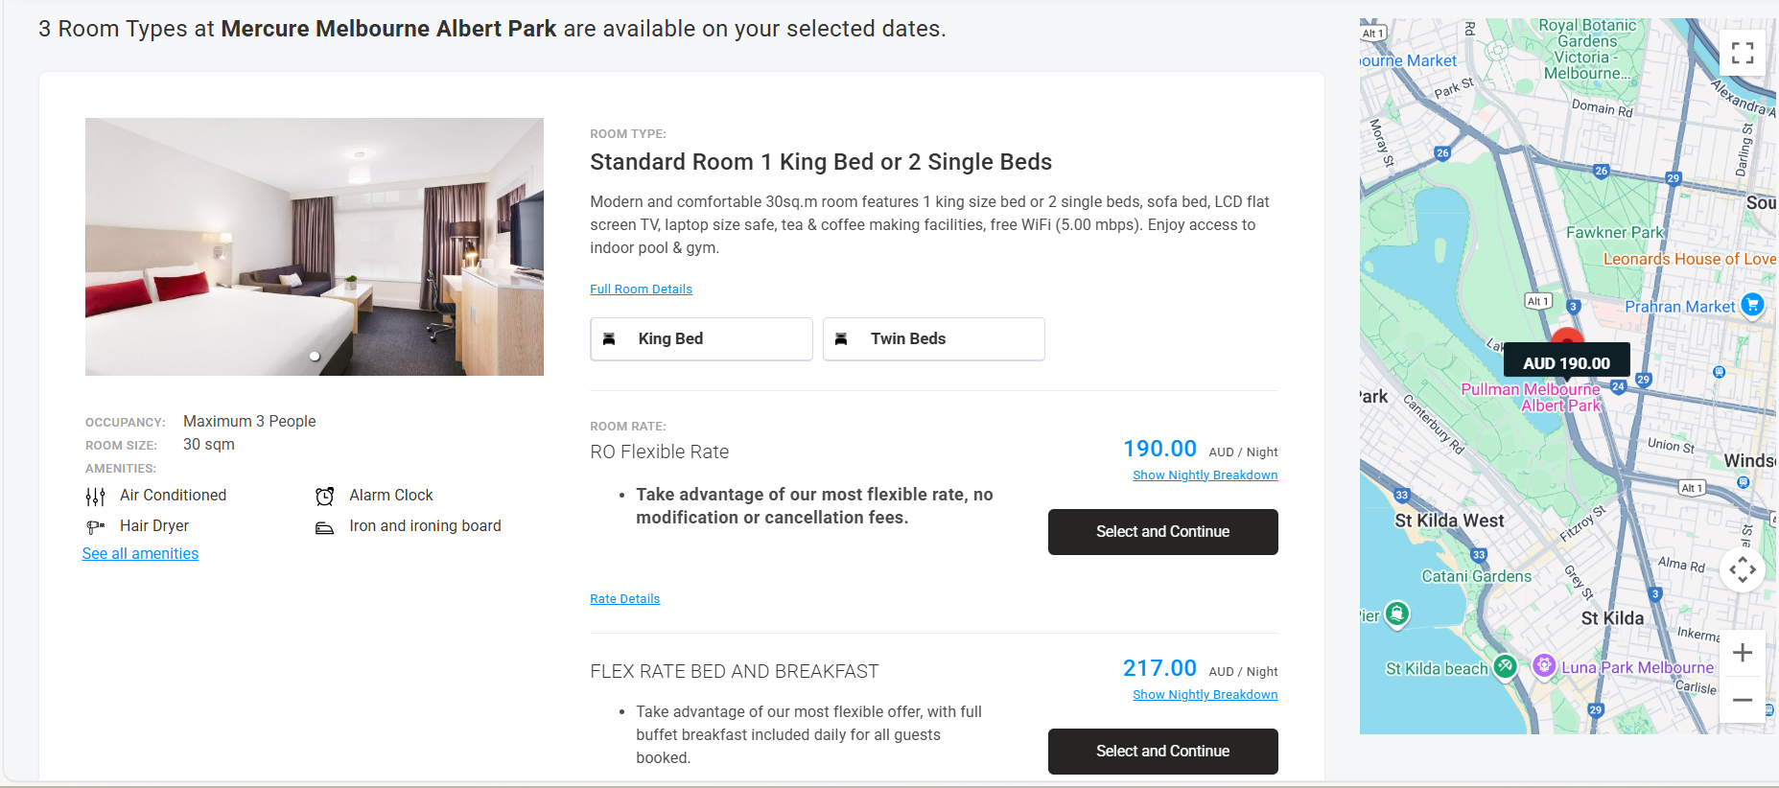
You will now be able to check out. No payment will be taken.

